DEPLOYMENT DIAGRAM

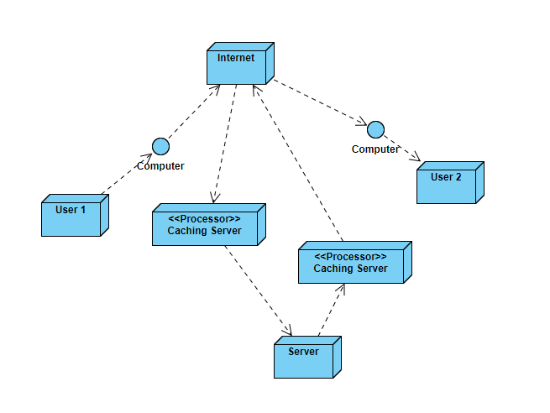

ACTIVITY DIAGRAM

